# Homework 3

Sandhya Mamidi(S02061097)

1.Downloaded the image zip file from Canvas and unzipped it.

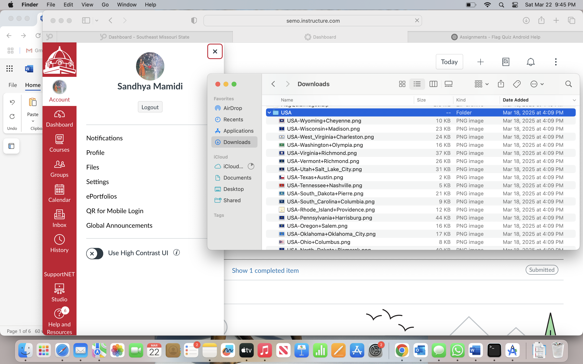

2. Make a copy of the FlagQuiz app as StateFlagQuiz app

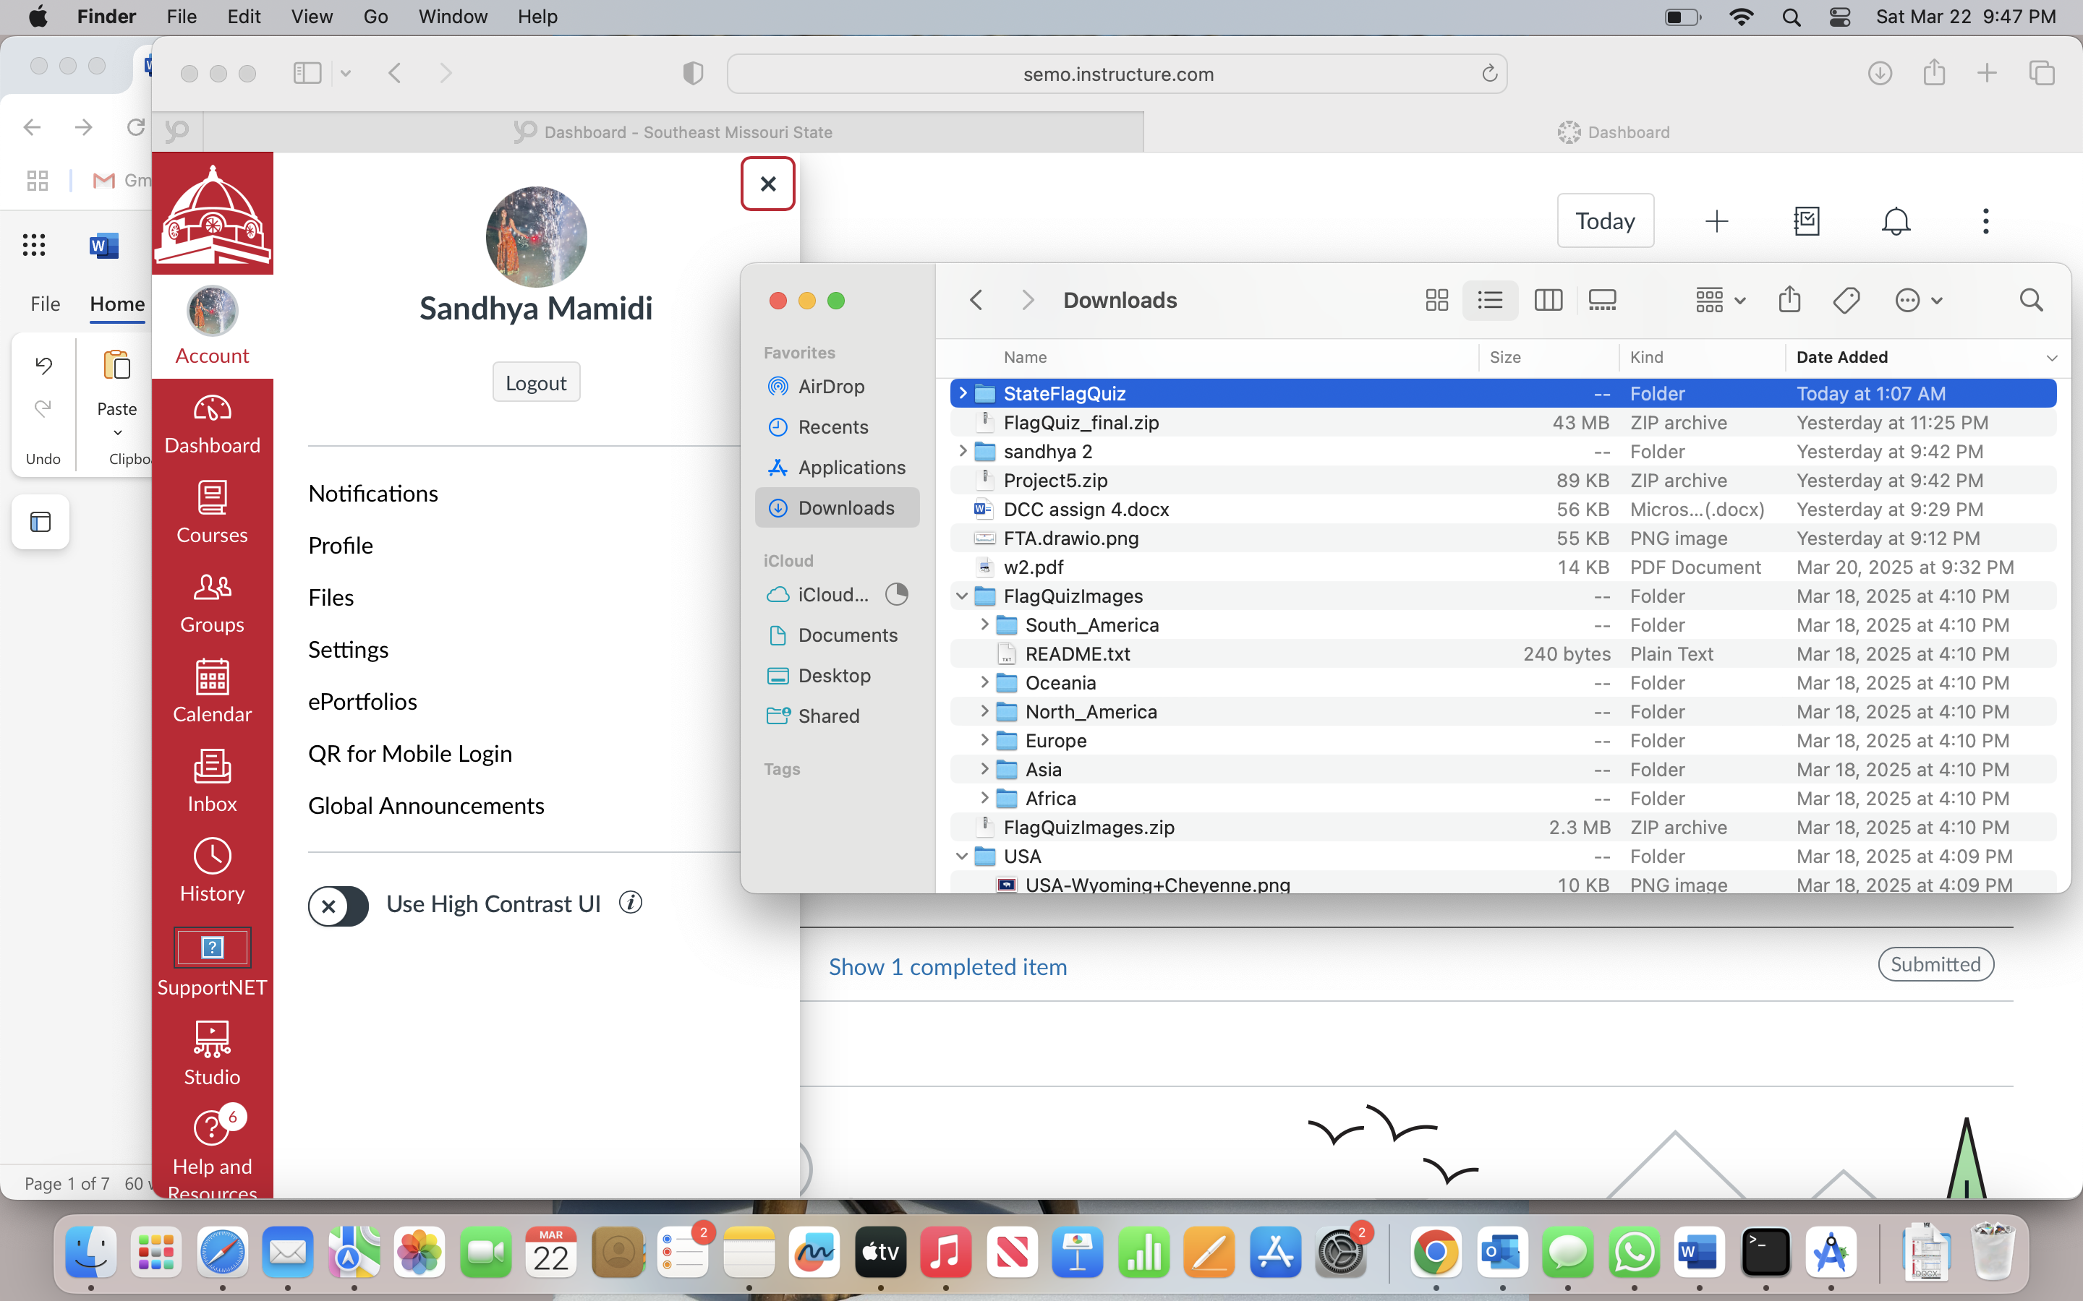

3. app/assets -> New -> Directory -> Name: USA -> Added the images into this folder

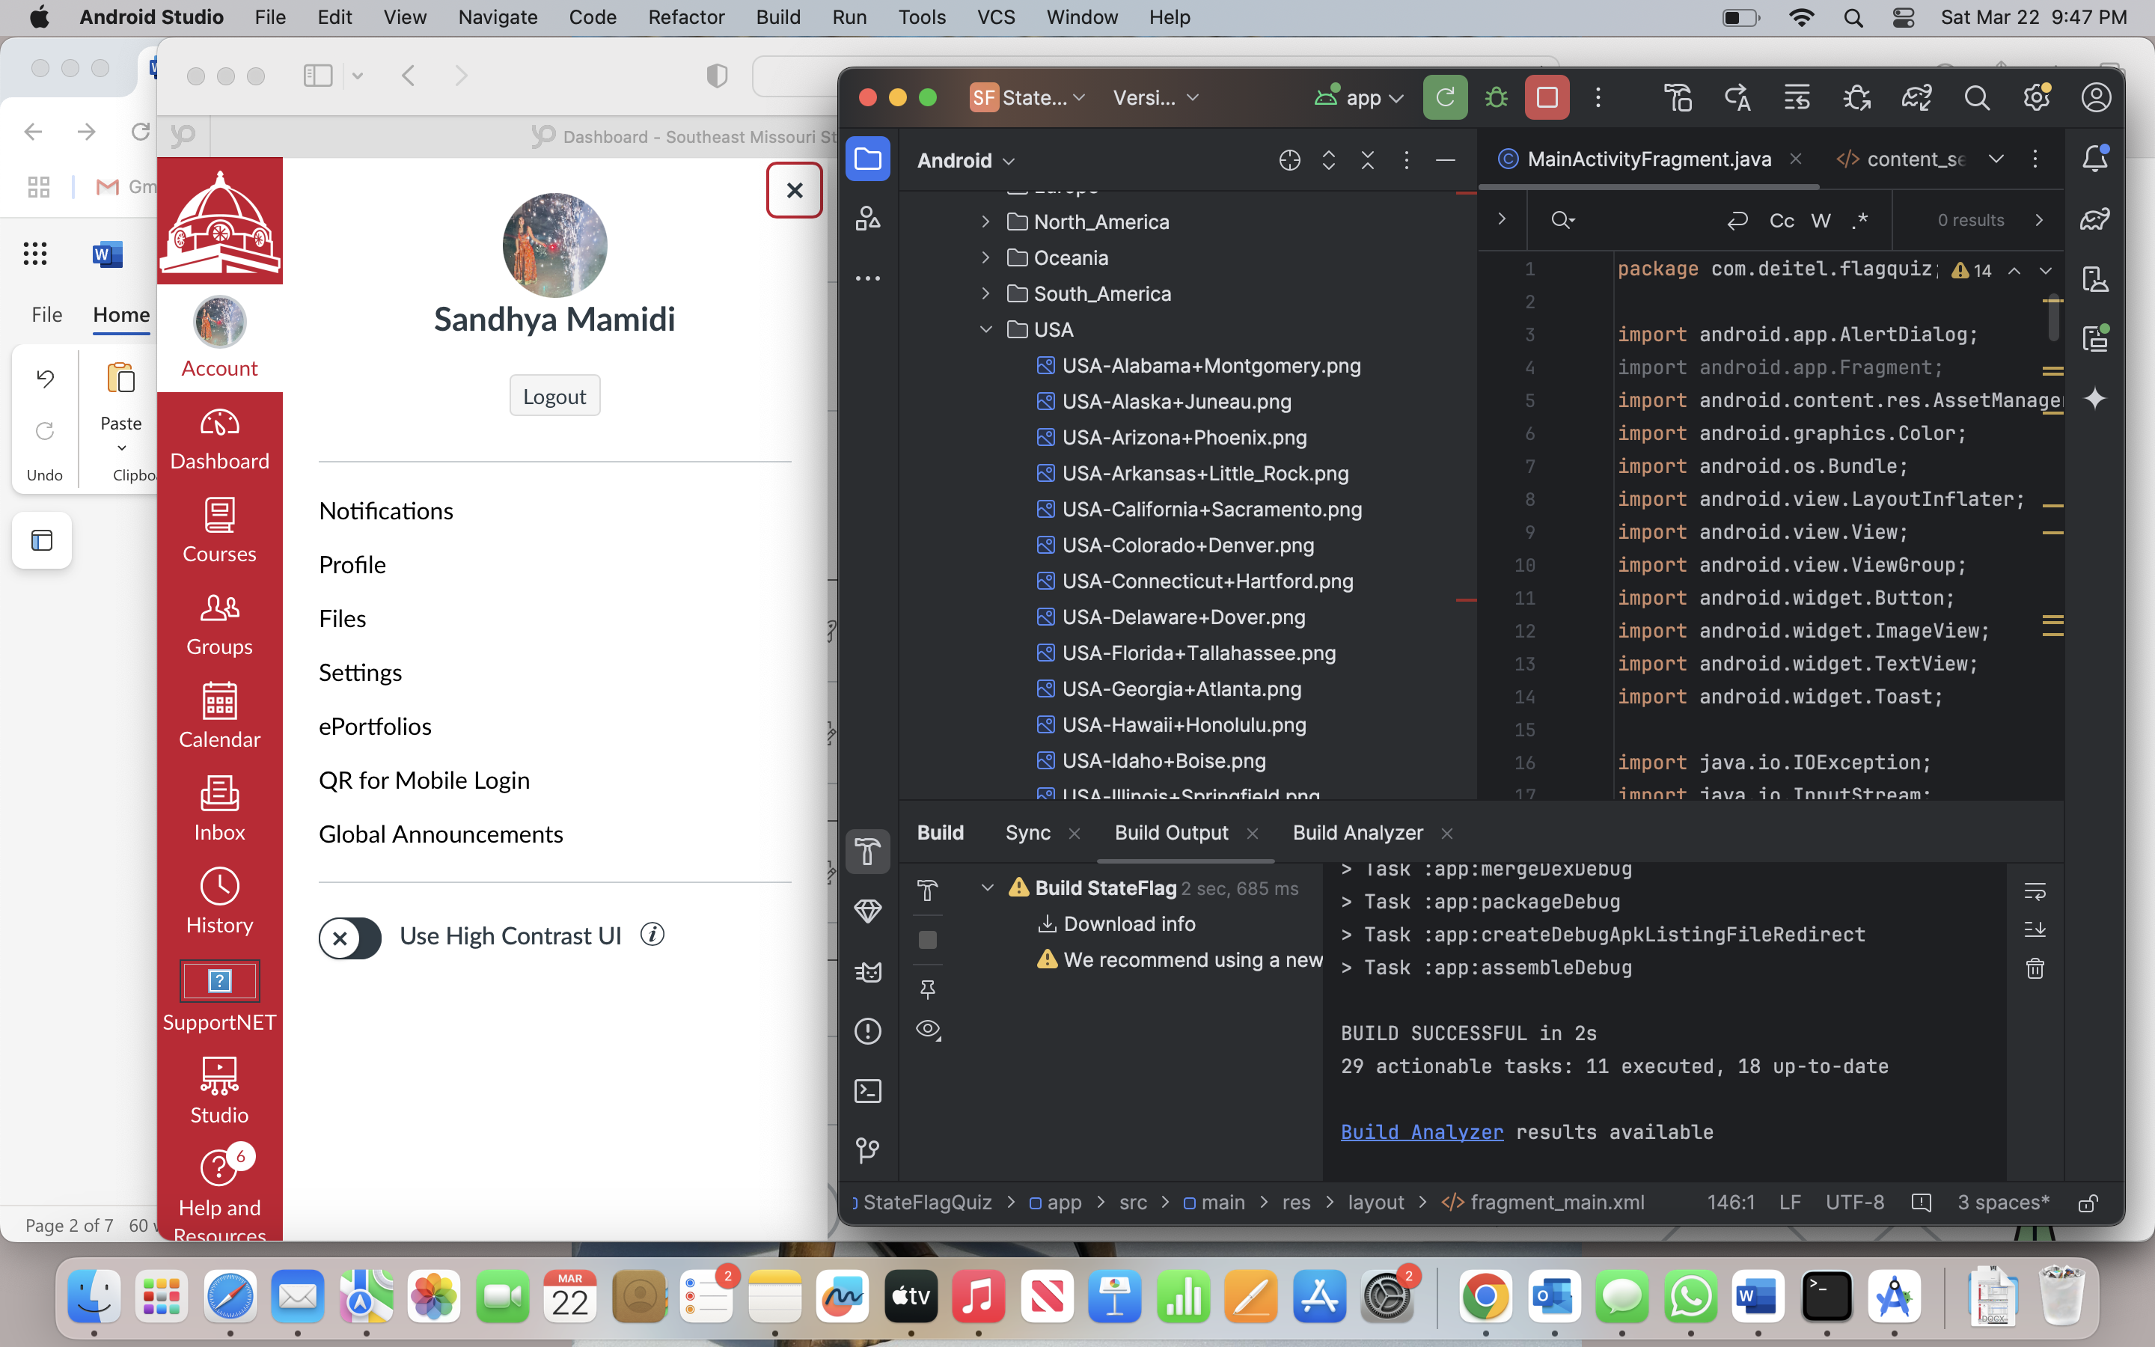

4. app/java/com.deitel.flagquiz/MainActivityFragment

parses the country flag file name and returns the country name

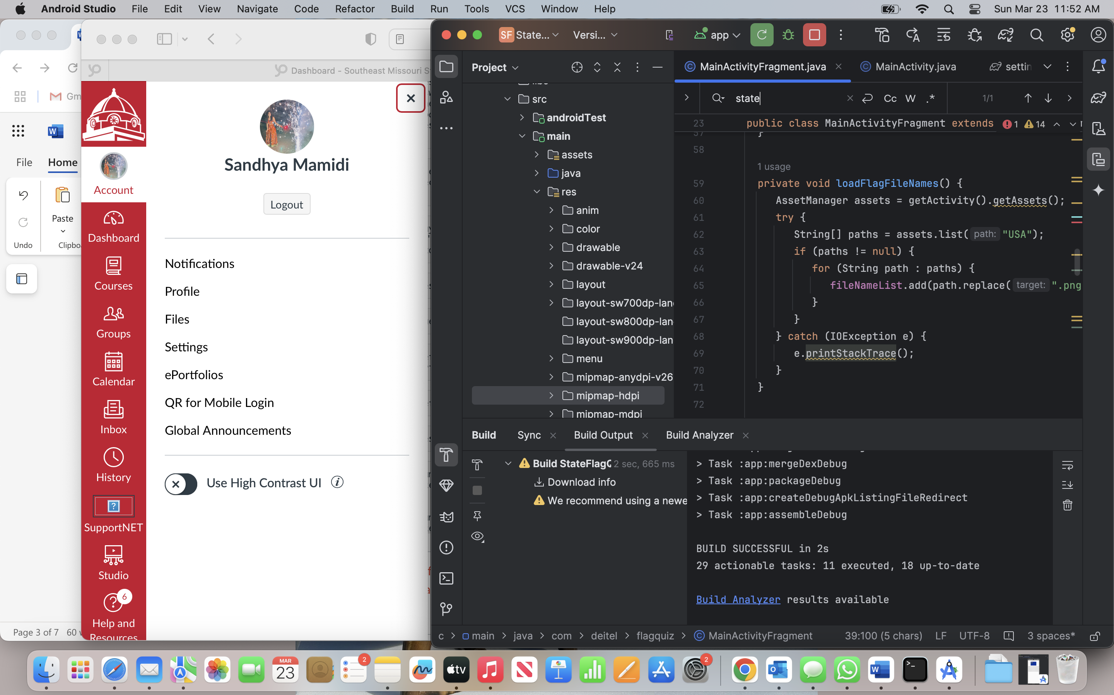

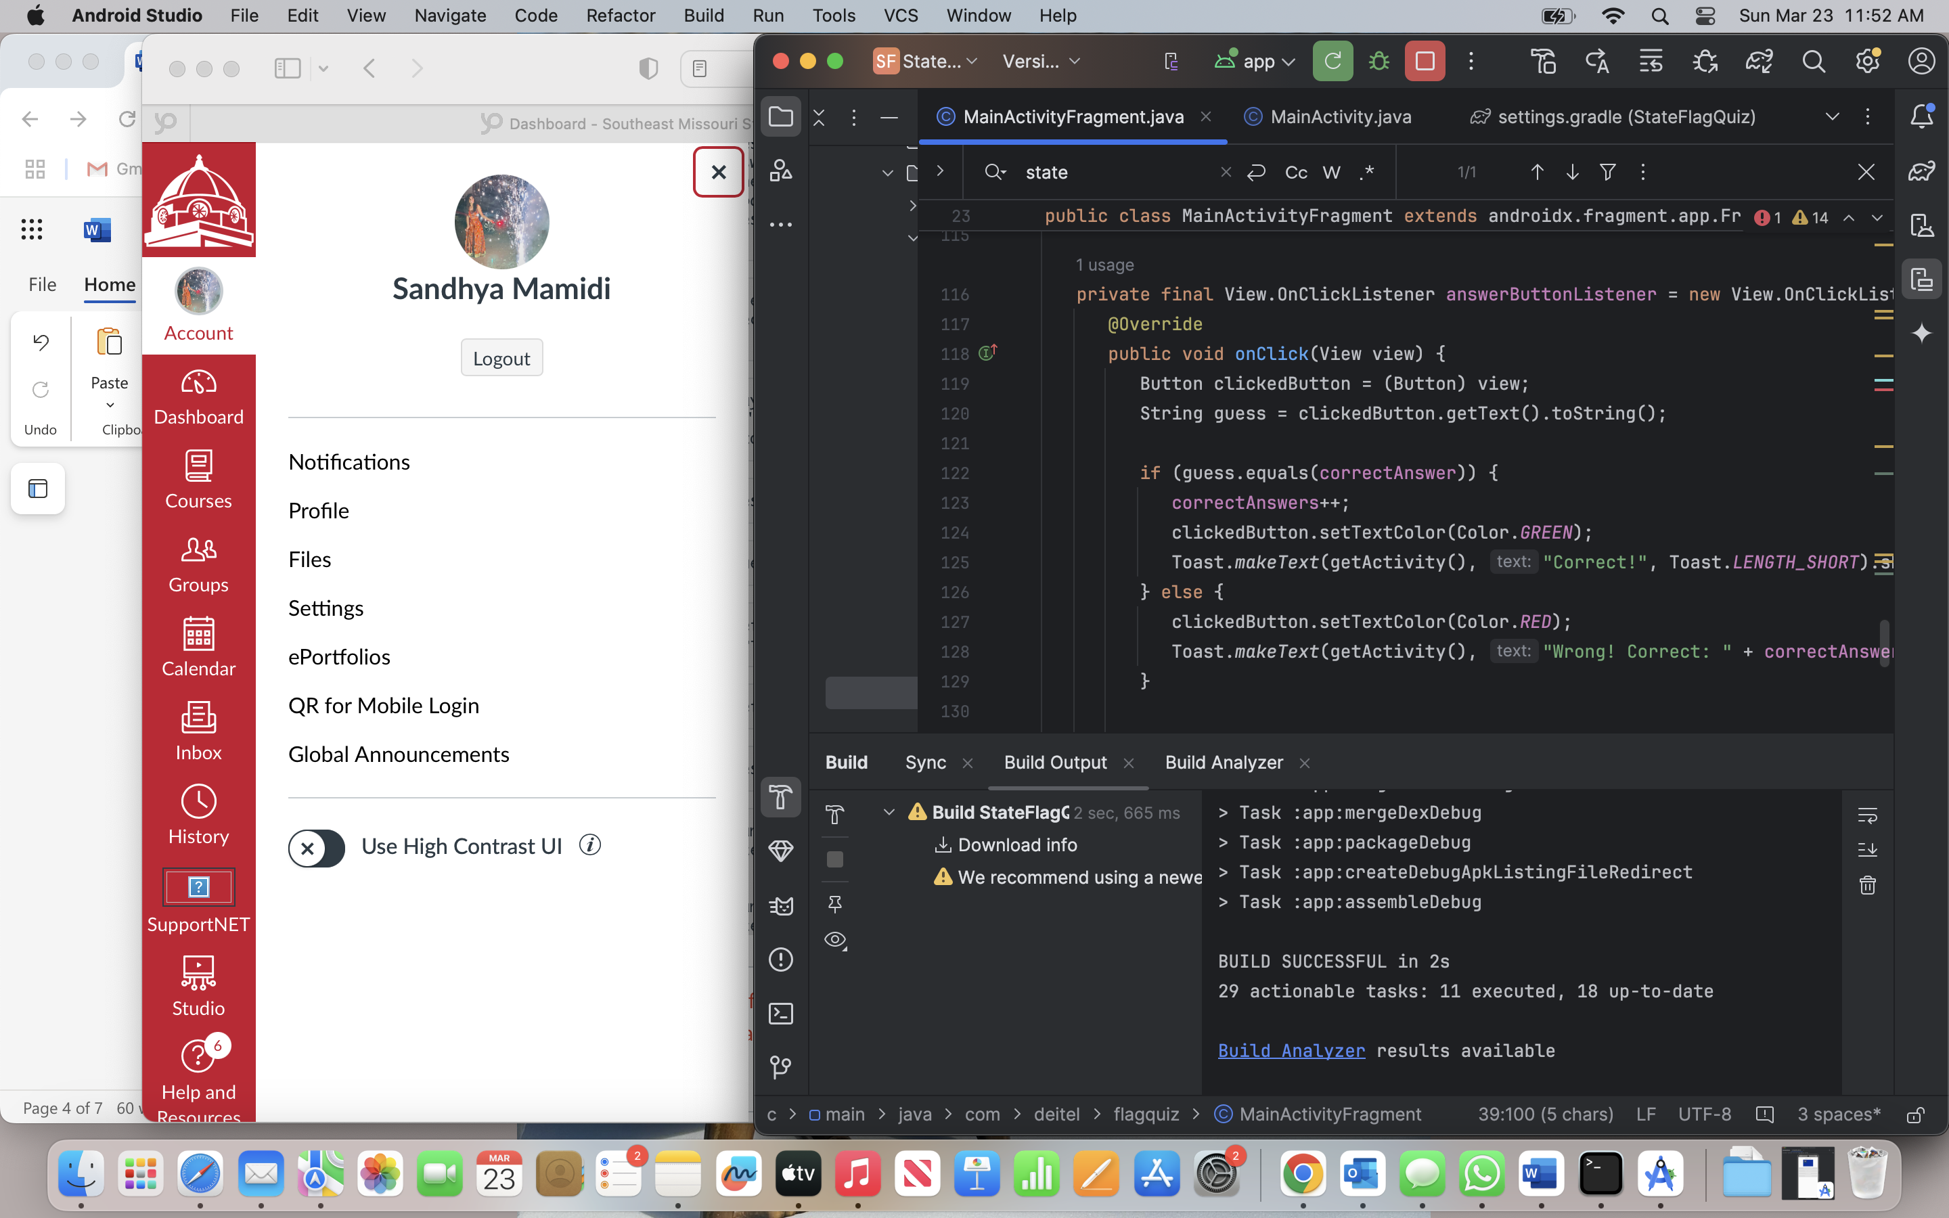

5. Modify app/res/values/strings.xml  
  
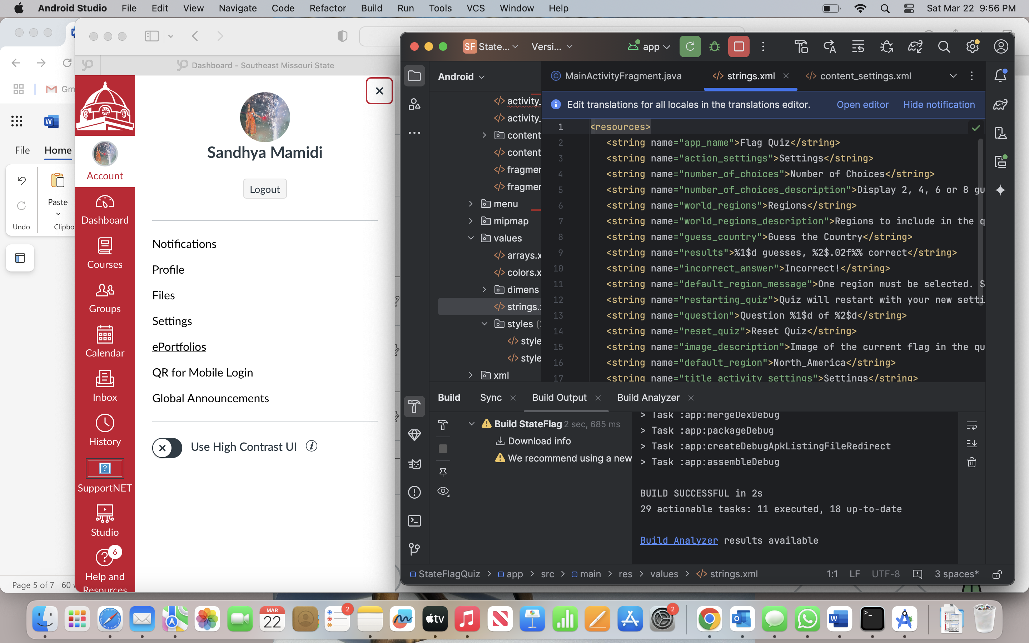

6. Modify app/res/values/arrays.xml

